Capstone Project
Name – Pratik Rokade
Ent id – pratik.r.rokade@accenture.com
Emp id – 14182788

1. Project Overview & Datasets
This document details the end-to-end data pipeline and application development for the RetailMart Group using Palantir Foundry. The project encompasses data ingestion, programmatic and visual transformations, object modeling, and the creation of an interactive operational application.

Datasets Utilized
1. Stores: Contains metadata for RetailMart locations, including Store ID, store Type, and Size (square footage).
2. Features: Contains time-series macroeconomic variables and regional indicators per store, including Temperature, Fuel Price, MarkDowns (1-5), CPI, Unemployment, and an IsHoliday boolean.
3. Sales: Transactional historical dataset detailing Weekly Sales aggregated by Store ID, Department, and Date.

- Data Transformation using Code Repositories –
- SQL –
Transformation 1 – Calculate Average Sales per Department Across All Stores :
Generate a summary view that computes AVG(Weekly_Sales) grouped by Dept across all stores for benchmarking department performance.

Code –

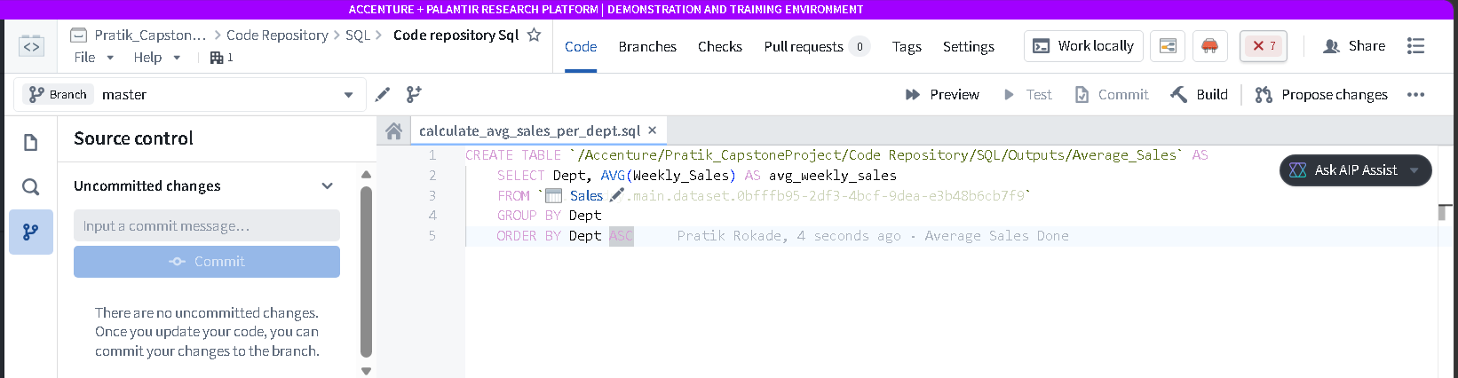
Output –
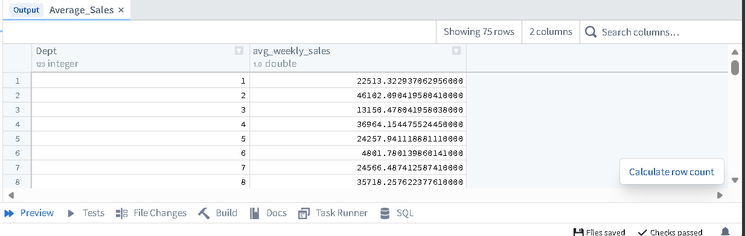

Build –
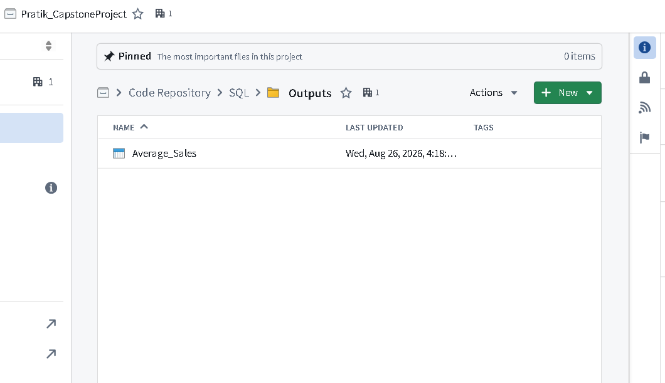

Transformation 2 – Aggregate Weekly Sales by Store and Month:
Create a summary table that groups Weekly_Sales by Store and extracts the month from Date. Use GROUP BY Store, MONTH(Date) and calculate SUM(Weekly_Sales) for monthly performance tracking.

Code –

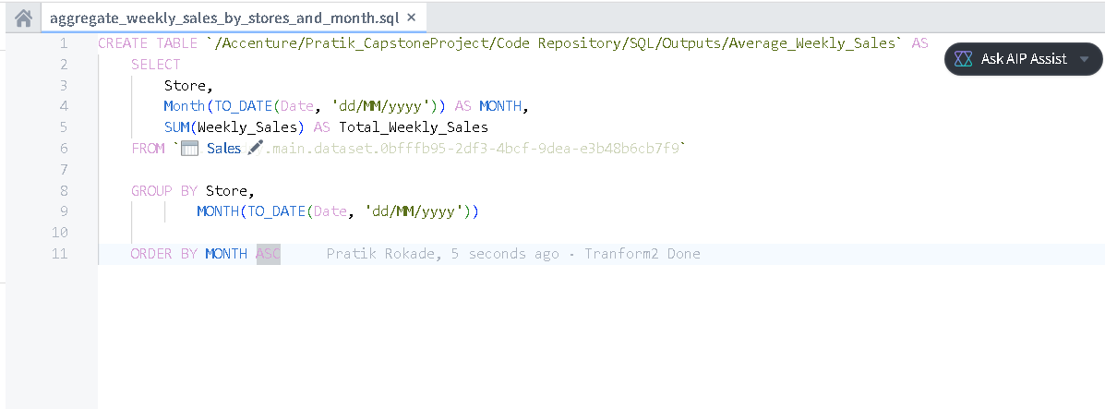
Output –

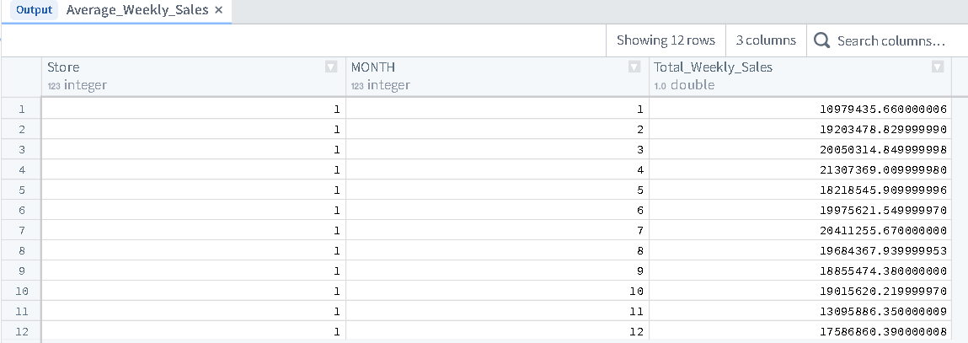

Build –
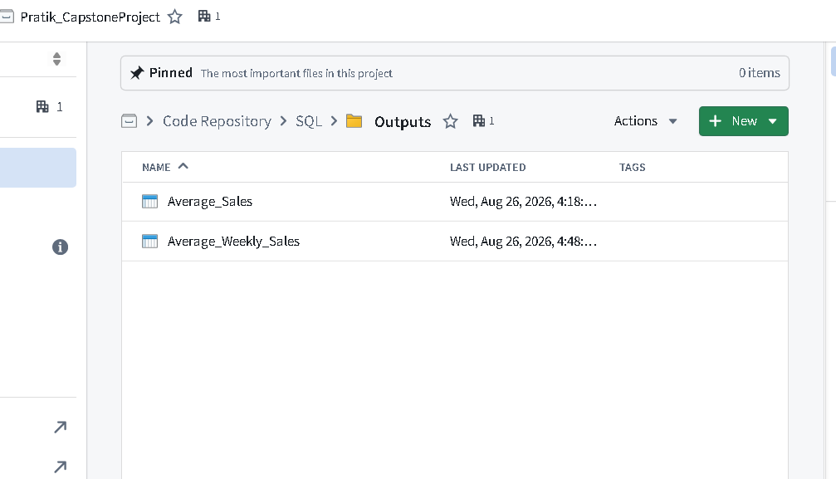
Transformation 3 - Join Sales and Store Attributes for Enhanced Analysis:
Perform an INNER JOIN between Sales and Stores on Store to enrich sales data with store attributes like Type and Size. Create a composite key store_dept_key by concatenating Store and Dept, then calculate the average weekly sales for each store_dept_key to enable department-level performance analysis.
Code -
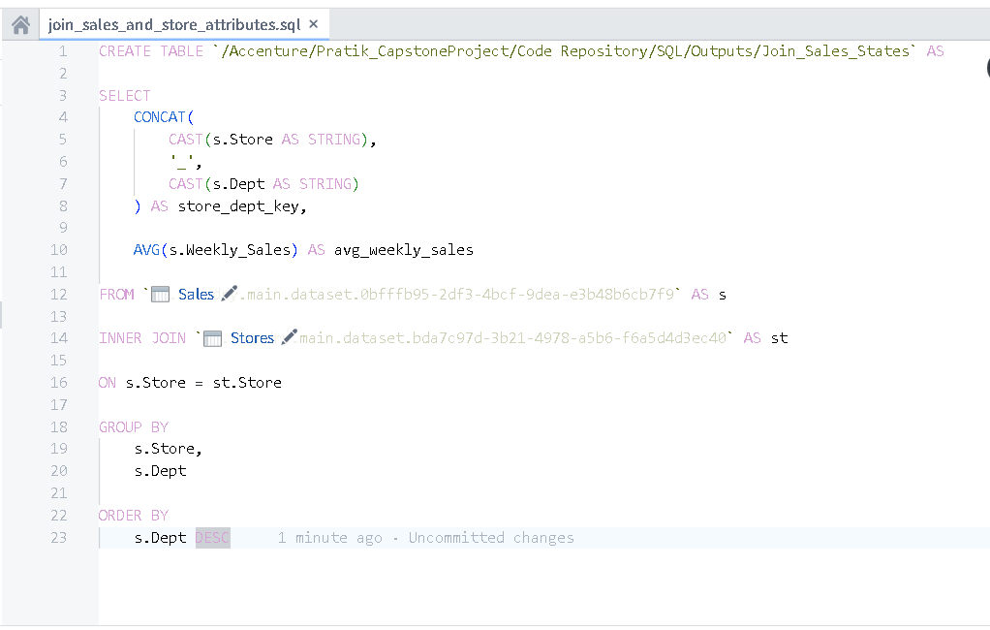

Output –

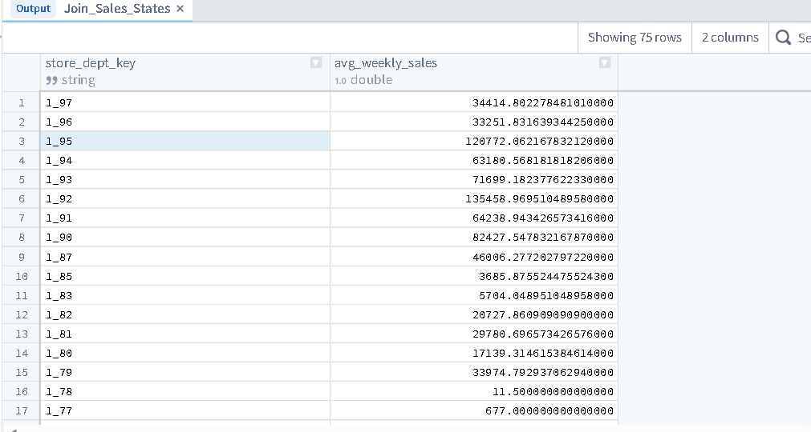
Build –
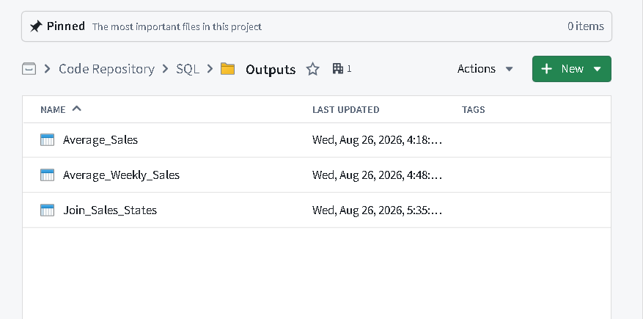

Transform 4 - Join Sales and Features for Holiday Analysis:
Use an INNER JOIN between Sales and Features on Store and Date. Filter records where is_holiday = TRUE and calculate total Weekly_Sales during holidays grouped by Store.
Code –
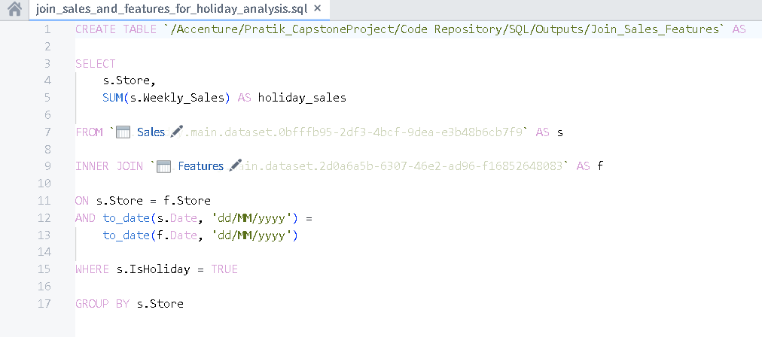
Output –
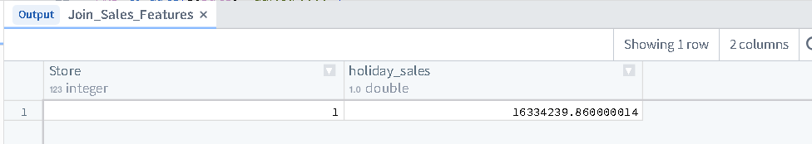
Build –
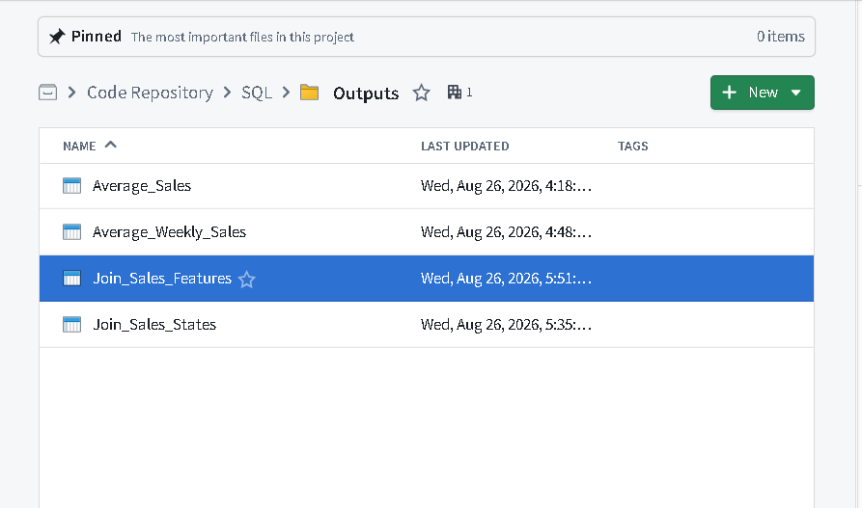
- Python –

Transformation 1 - Handling Missing Values and Create Unique Record ID: Replace NA in MarkDown1–MarkDown5 with 0 and fill missing CPI and Unemployment with their respective column means. Then, create a new column record_id by concatenating Store and Date to uniquely identify each record in Features.
Code –

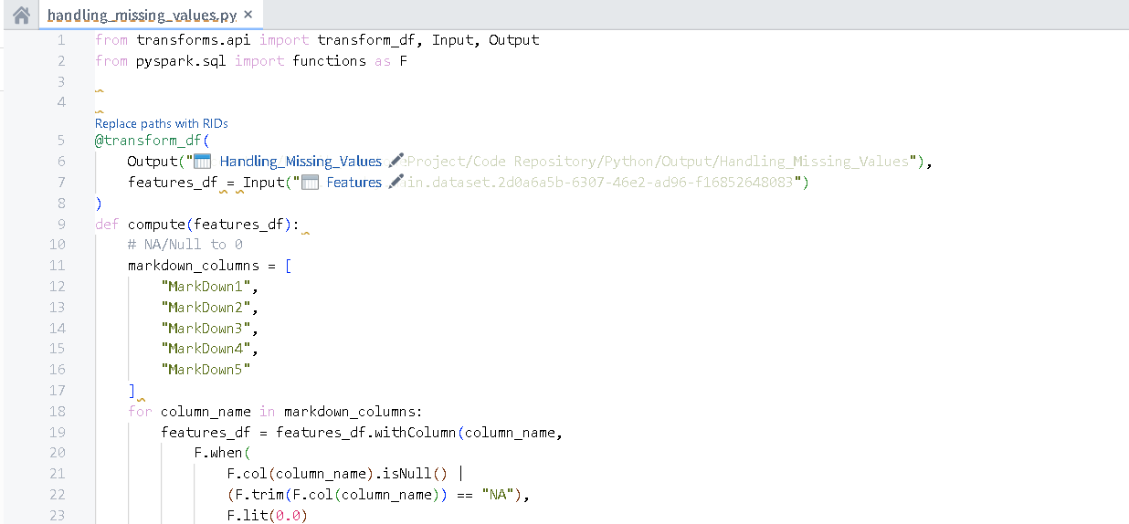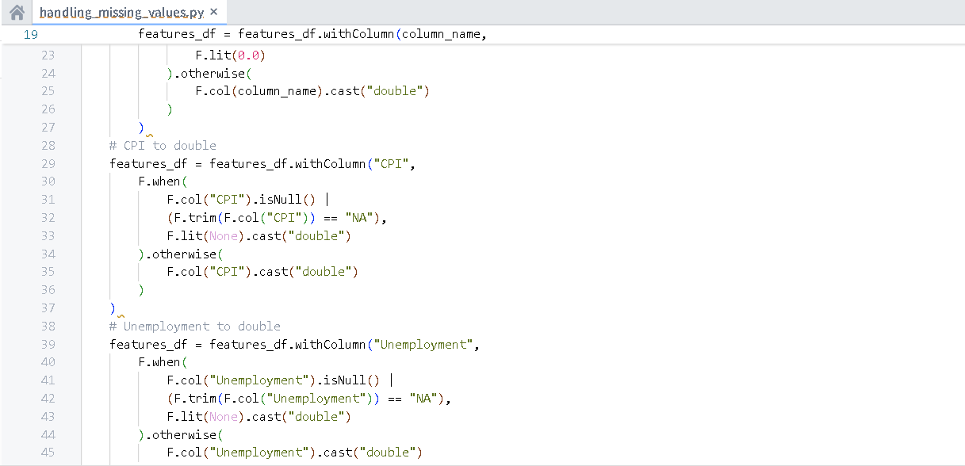

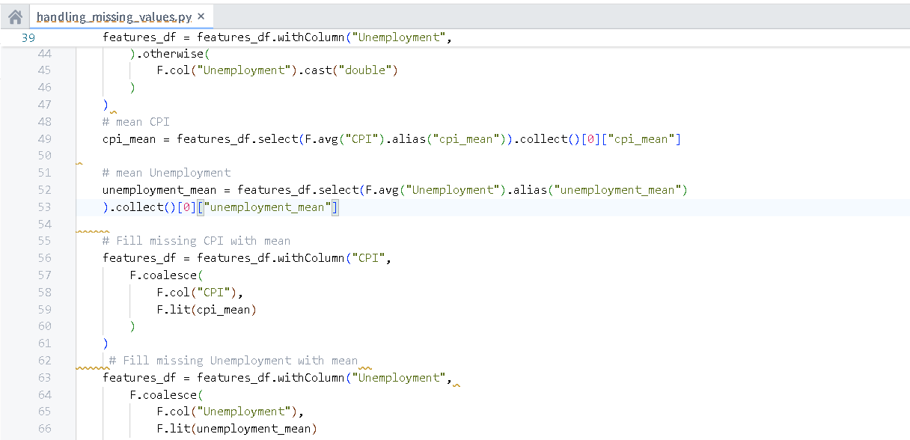
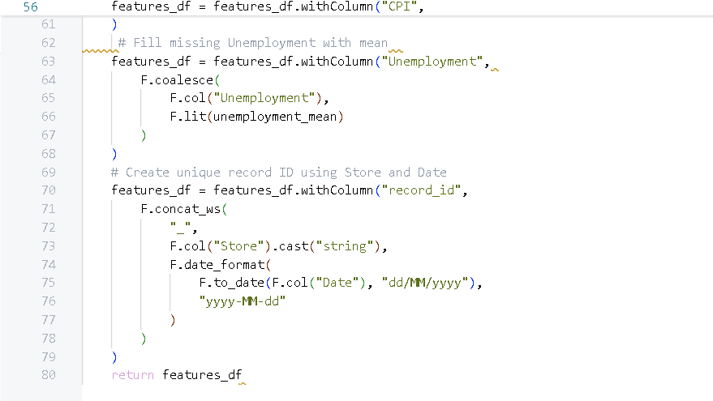
Output –
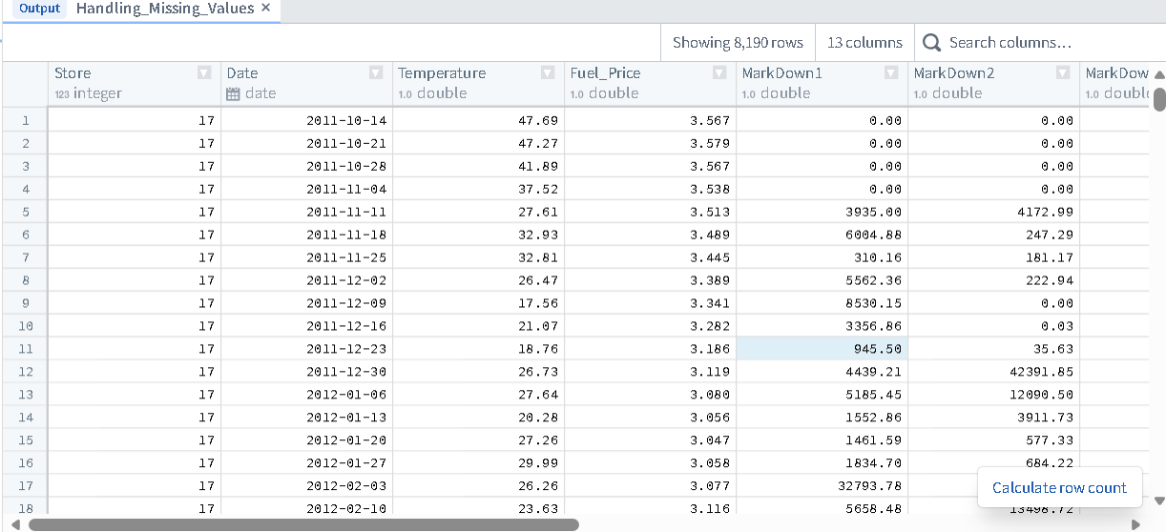
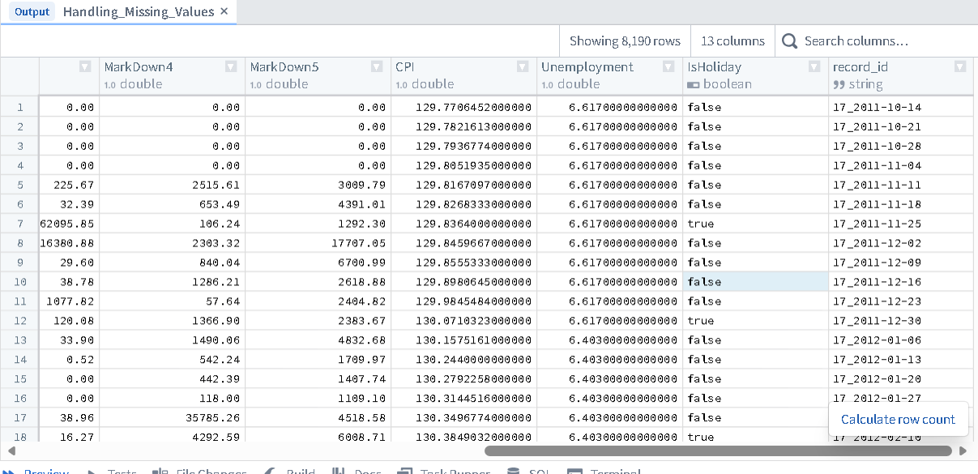
Build -
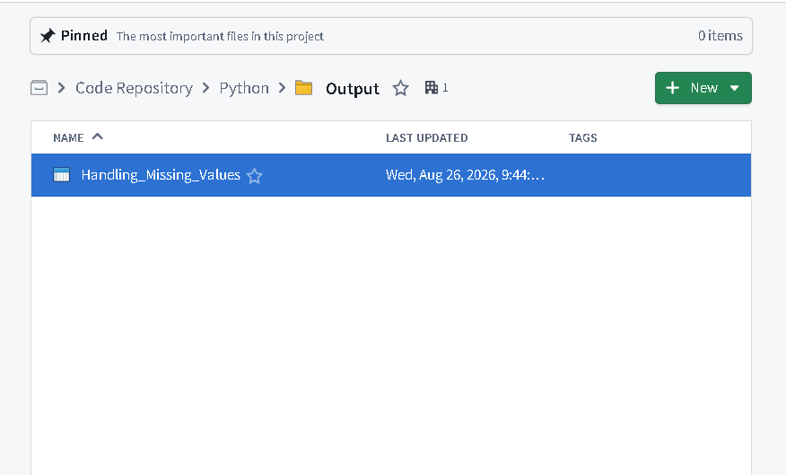
Transformation 2 - Renaming Columns and Standardize Format:
Rename columns in Features to snake_case (e.g., Fuel_Price → fuel_price, IsHoliday → is_holiday). After renaming, create a new column store_date_key by combining store and date for uniqueness.

Code –
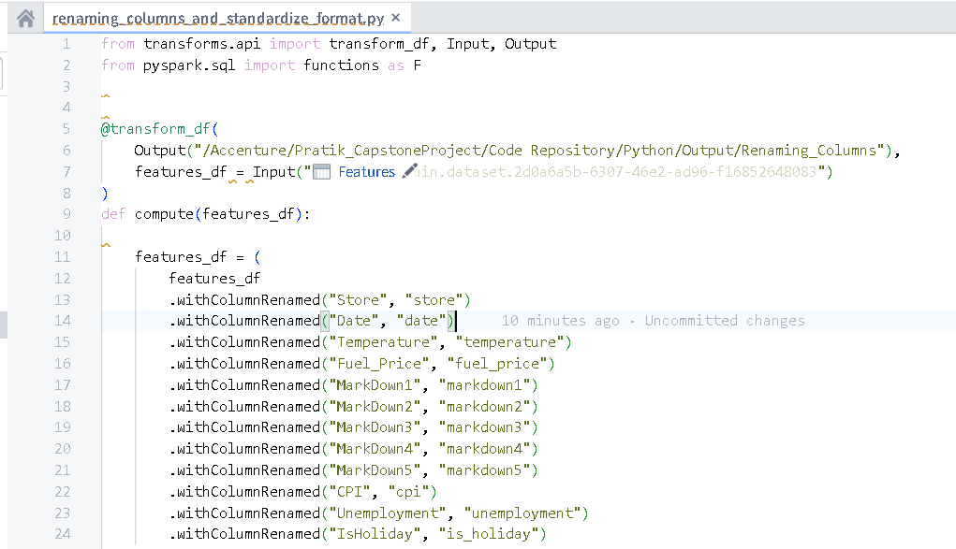
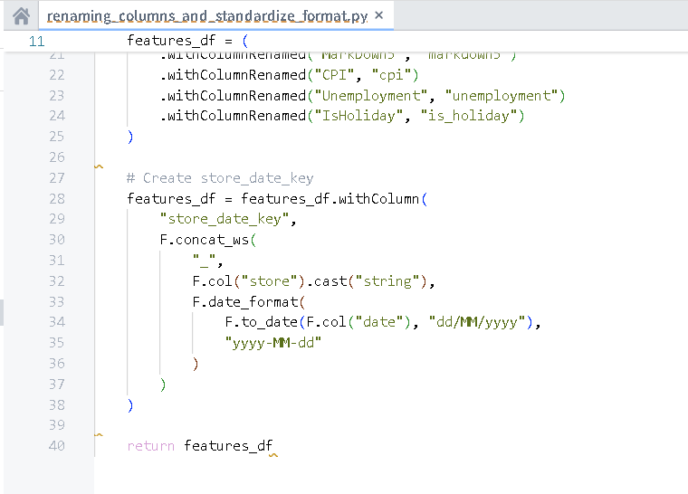

Output –
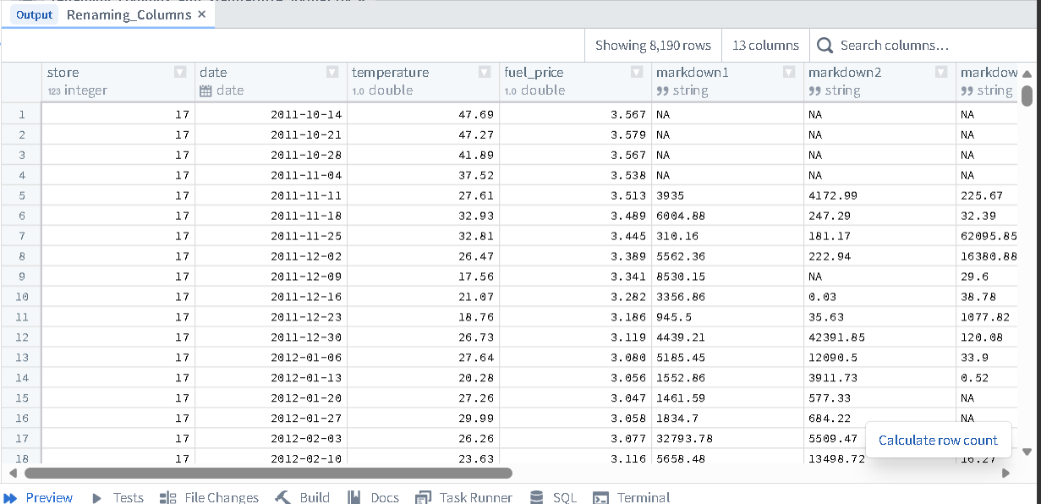
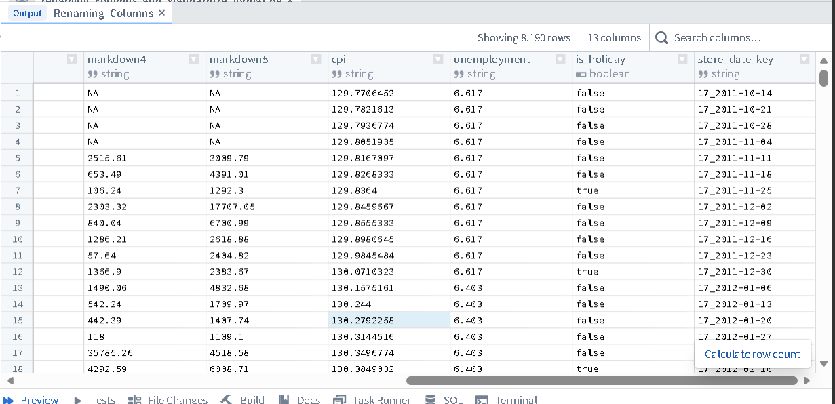
Build –
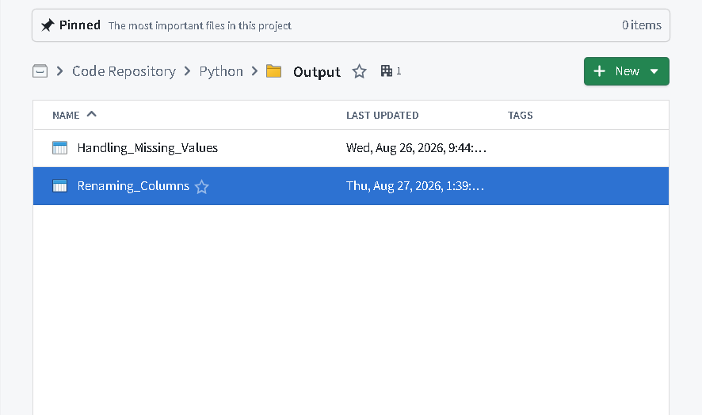

Transformation 3 – Validating and Converting Data Types:
Ensure that numeric fields are stored in the correct data type. Columns like Weekly_Sales, Temperature, Fuel_Price, MarkDown1–5, CPI, and Unemployment should be of type DoubleType for accurate numerical operations.
Code –
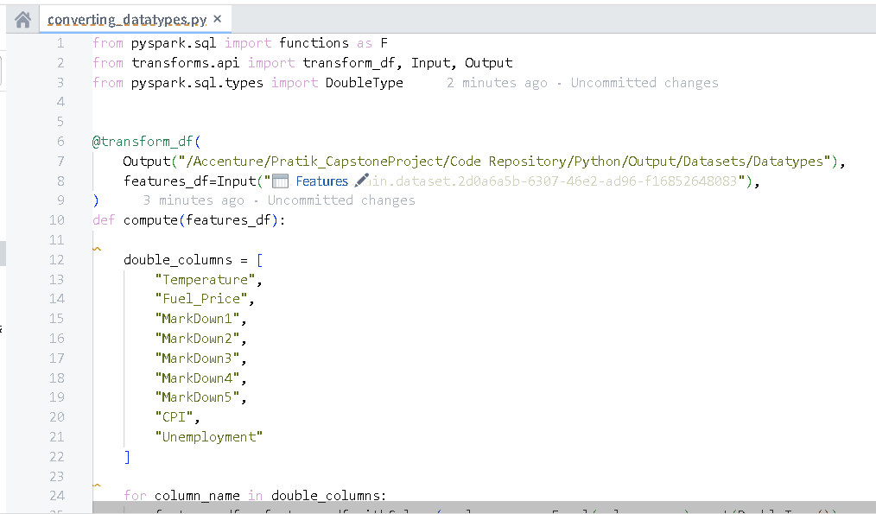
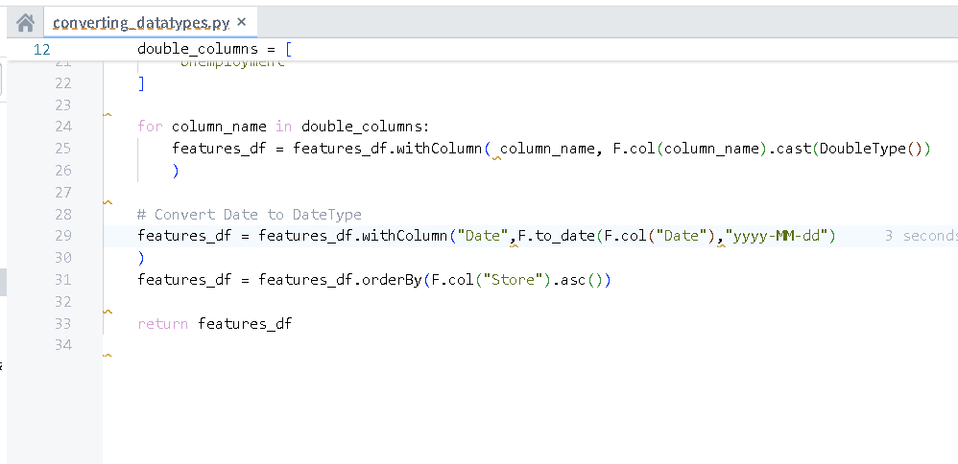
Output –
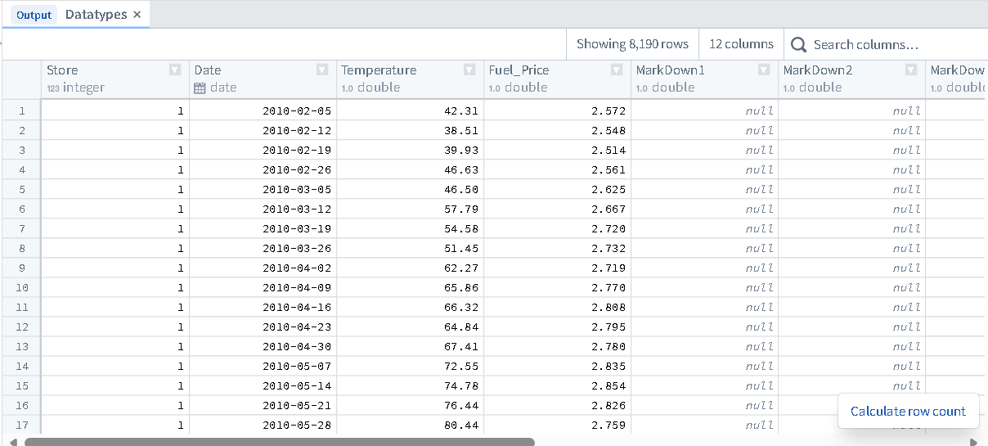

Build –
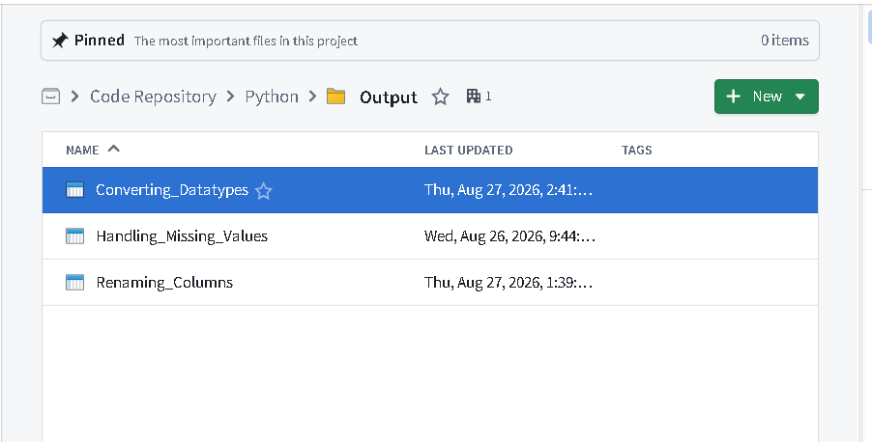

Transformation 4 - Drop Unnecessary Columns and Add Composite Key:
Drop MarkDown1–MarkDown5 columns from Features if not needed for analysis. After dropping, create a new column store_type_key by combining Store and Type from Stores.

Code –
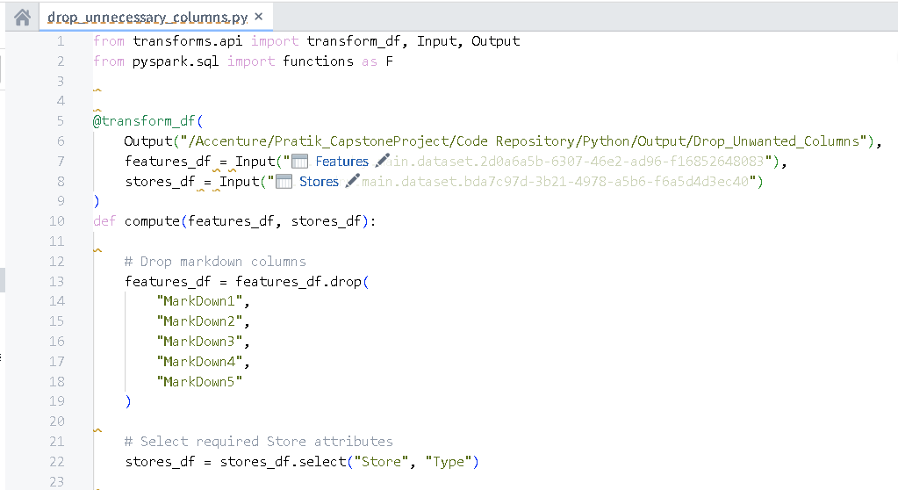
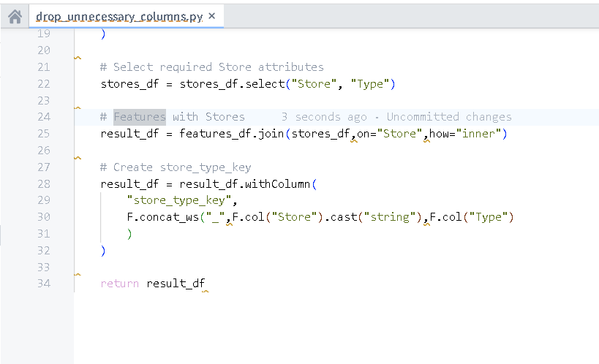
Output –
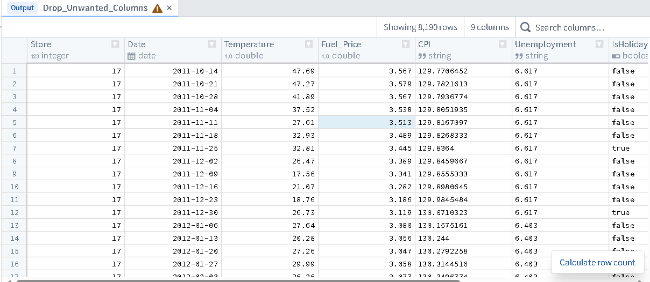
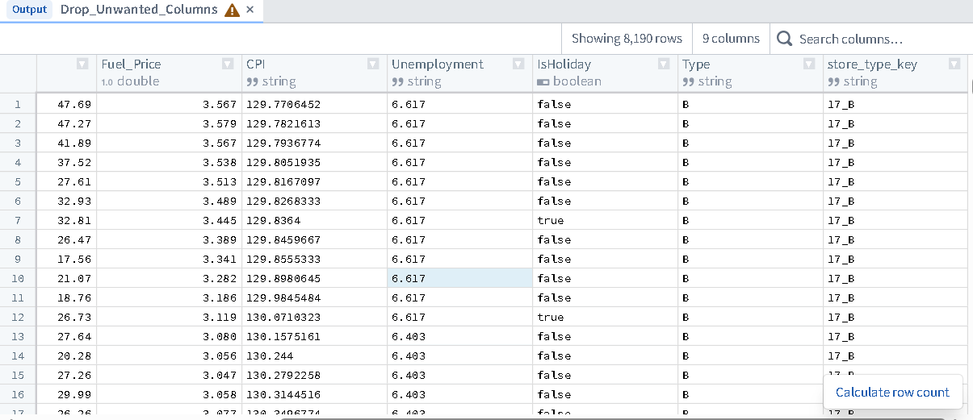

Build –
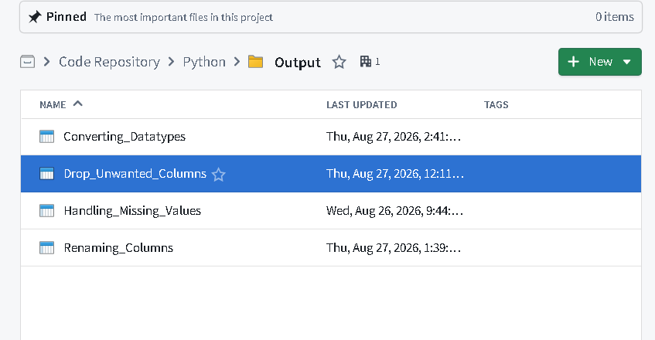
Transformation 5 - Create Derived Column and Unique Department Key:
After joining Sales and Stores, create a new column sales_per_sqft by dividing Weekly_Sales by Size. Then, add a column store_dept_key by concatenating Store and Dept to uniquely identify each department-level record.
Code –
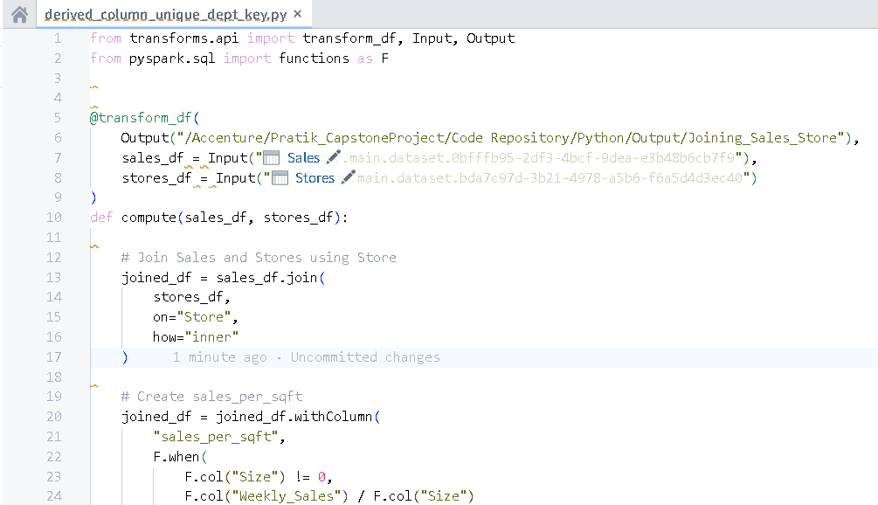
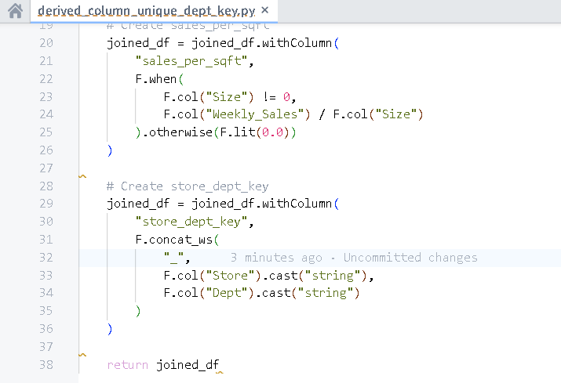

Output –
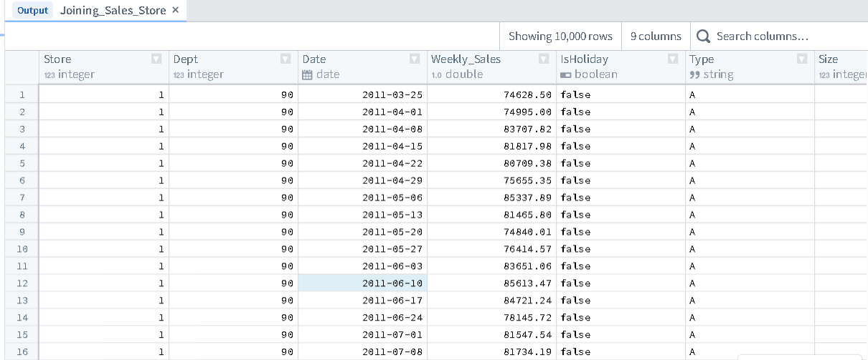
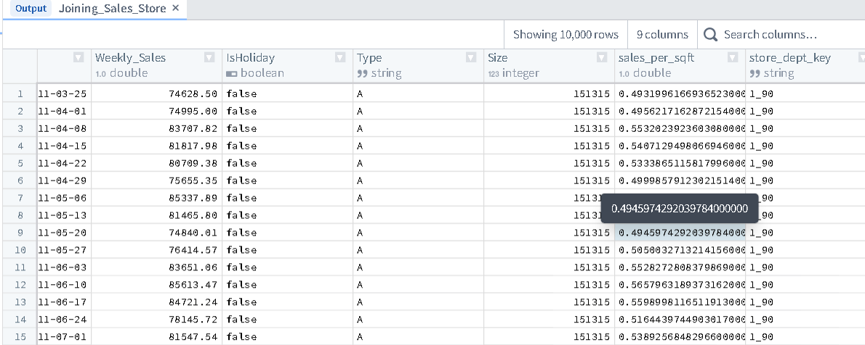
Build -
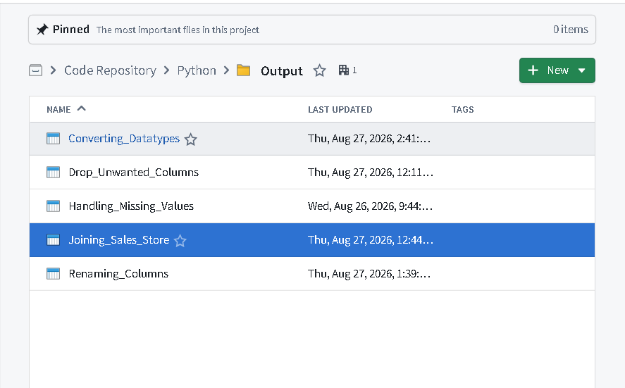
- Data Integration using Pipelines
The Pipeline Builder in Foundry allows users to design and execute data transformation workflows without writing code.
Execution Steps:
• Imported the three datasets as starting nodes.
• Built join nodes linking Features to Stores, and Sales to Stores.
• Deployed the pipeline to output 'Cleansed' datasets for ontology backing.
- Data Cleansing Pipeline ➢ Oversee Missing Values: Replace NA or null values in MarkDown1–5, CPI and Unemployment columns with 0 in Feature dataset.
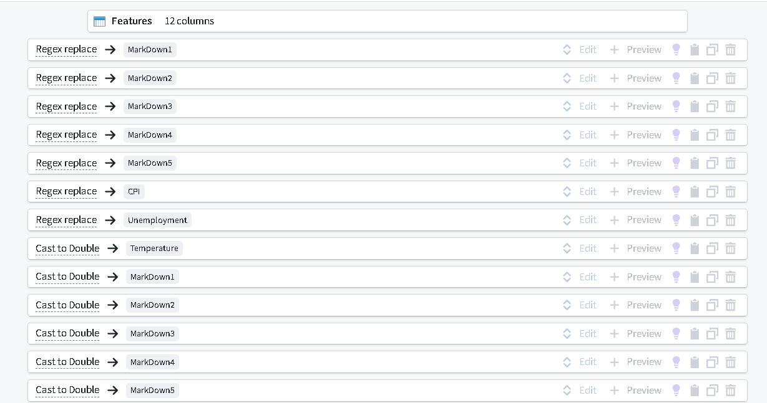
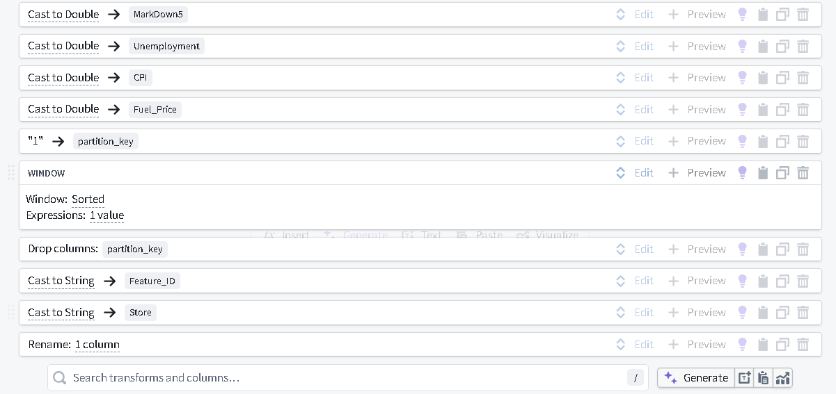
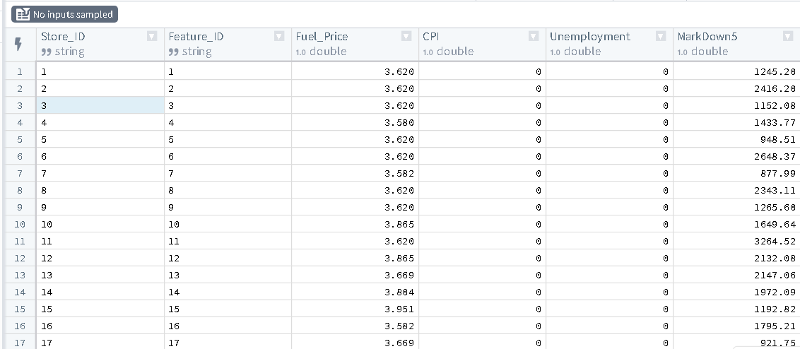
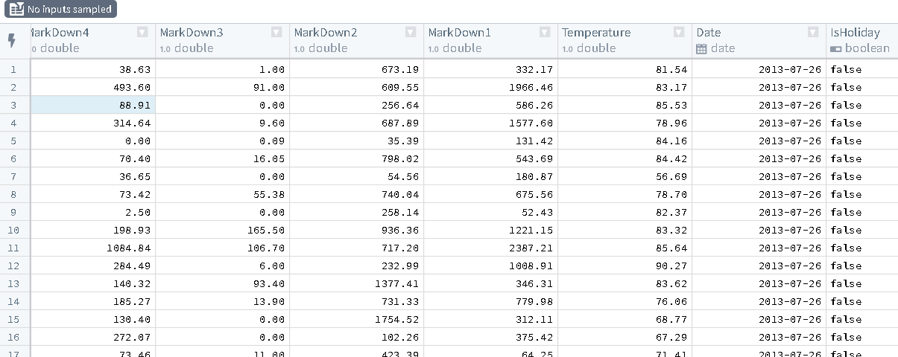

- Validate Data Types: Ensure numeric fields such as Weekly_Sales, Temperature, Fuel_Price, MarkDown 1-5, CPI, and Unemployment from Feature and Sales are stored as Double.

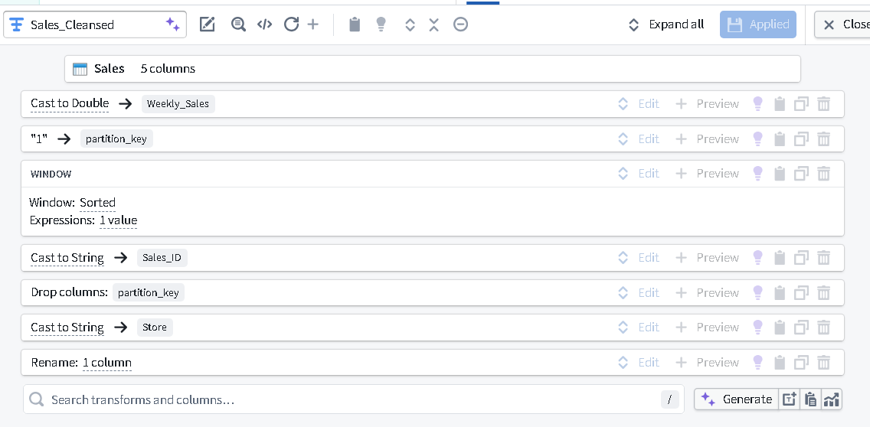
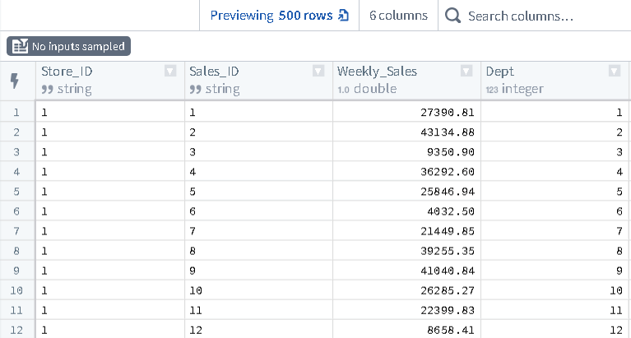
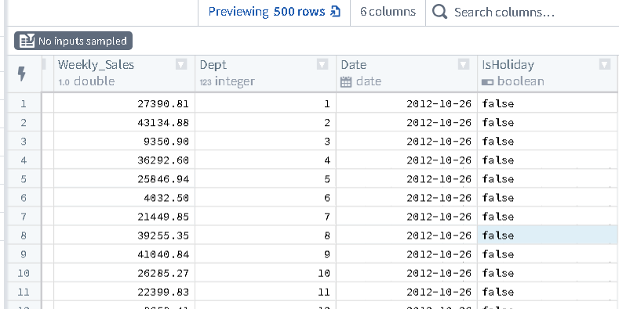
- Create Key Attributes: Create Primary Key column in Feature and Sales dataset namely Feature_ID and Sales_ID in String datatype
- Column Rename: Rename the column named Store to Store_ID in all three datasets and make it String
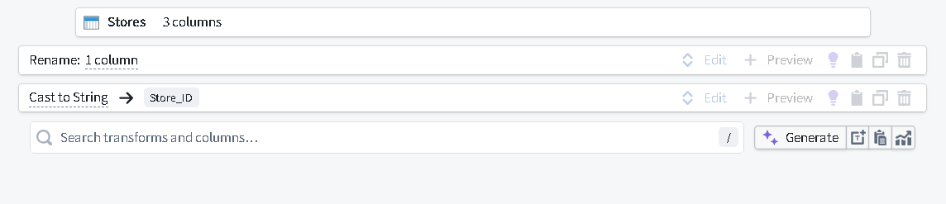
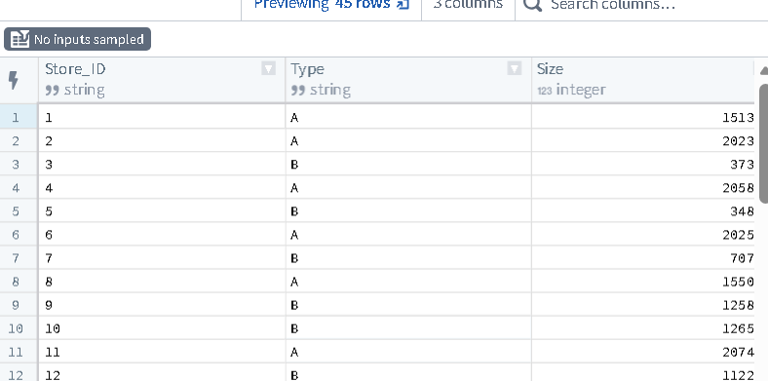
- Combine Data: Combine the above transformed databased on key attributes and create two more datasets namely Features_Stores and Sales_Stores.
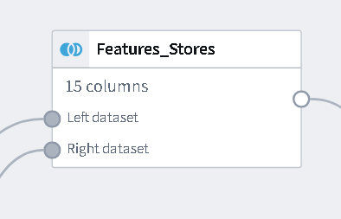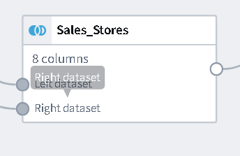

Final Pipeline –
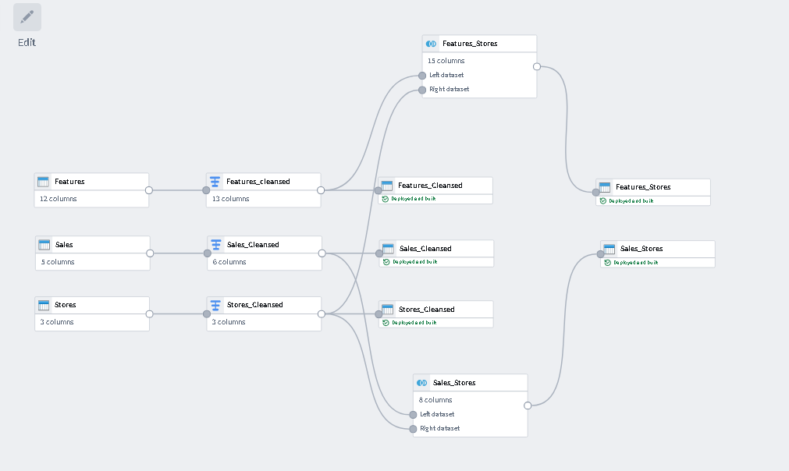

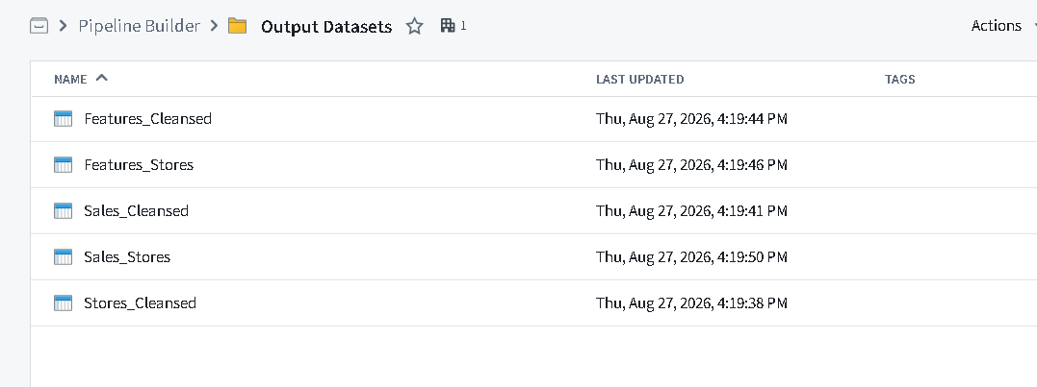

- Create and explore Objects using Ontology Manager
Component Utilization: Ontology Manager translated tabular data into a digital twin of the retail environment, allowing applications like Workshop to query objects and relationships rather than raw tables.
Execution Steps:
• Created three primary Object Types: CleansedStores, CleansedSales, and CleansedFeatures.
• Mapped Primary Keys and Title Keys to the respective Object Types.
• Established One-to-Many relationships (Link Types) connecting Store to Sales and Store to Features via Store_ID.

- Object Creation: Create three core business objects namely CleansedFeatures_Obj_, CleansedSales_Obj_, CleansedStores_Obj_ using the Feature_cleansed, Sales_Cleansed and Store_Cleansed datasets.

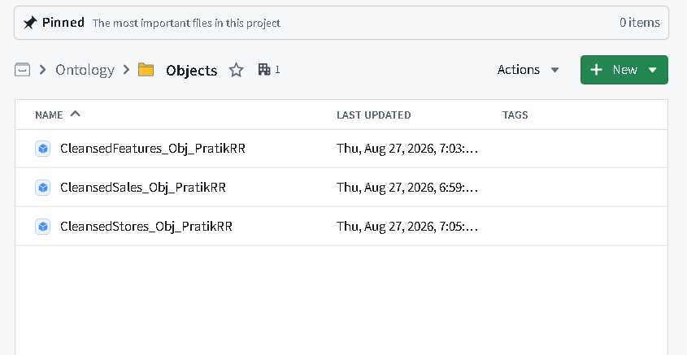
- Link Creation: Established one-to-many relationships between: • Stores → Sales (via Store_ID) • Stores → Features (via Store_ID)
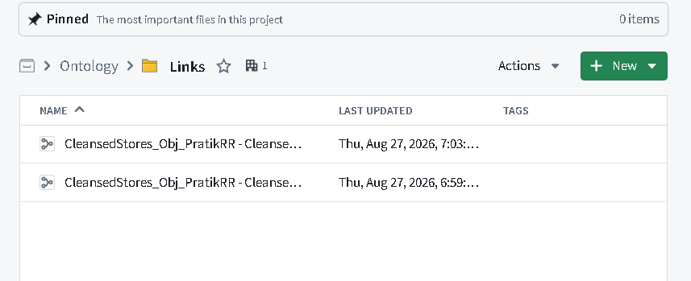

Features - Stores
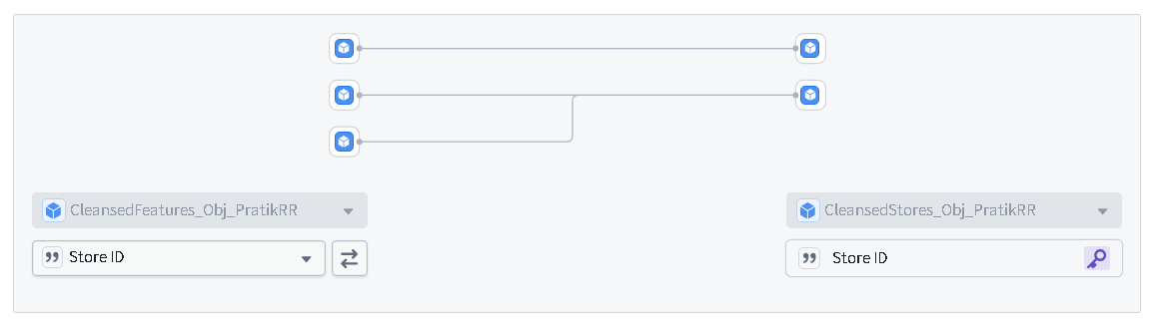

Sales - Stores
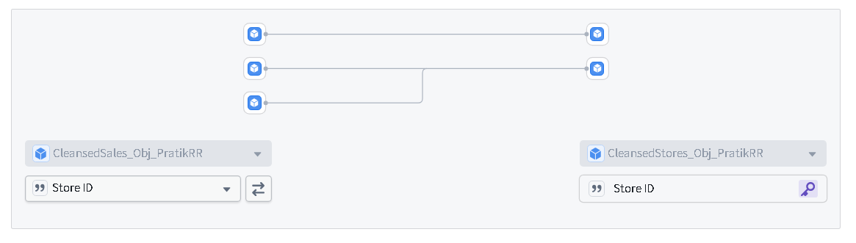

Data Lineage –

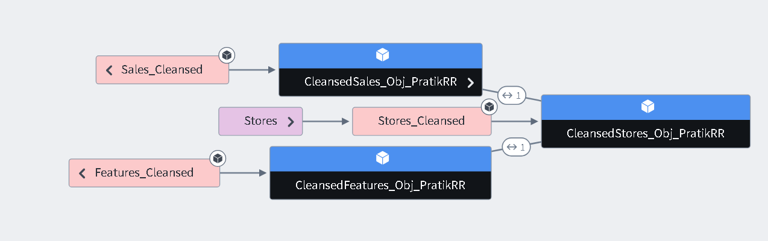

- Data Analysis using Quiver –
Component Utilization: Quiver was used to perform object-based analysis and visual aggregations, leveraging the ontology links to find correlations between store properties and sales metrics.
Execution Steps:
• Imported CleansedSales and CleansedStores objects.
• Applied grouped aggregations to calculate the Top 5 Stores by Average Weekly Sales.
• Created linked charts analyzing the impact of holidays on specific departmental sales.

- Analyze Sales Performance: Compare Weekly_Sales across stores, departments, and time periods to identify top performing stores or departments.
- Weekly sales across stores –

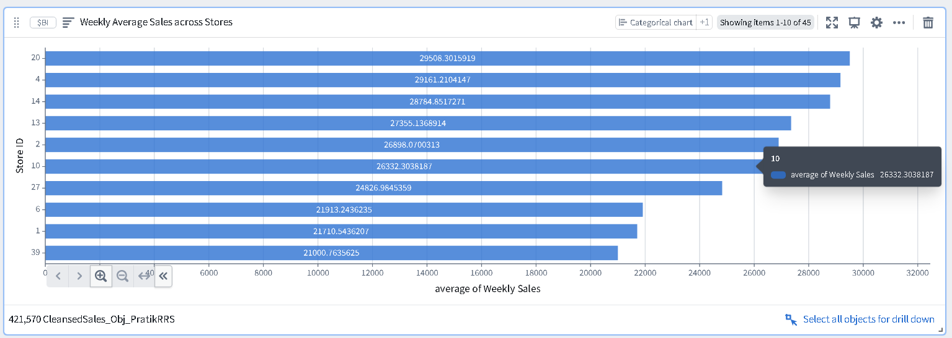

Weekly sales by departments –
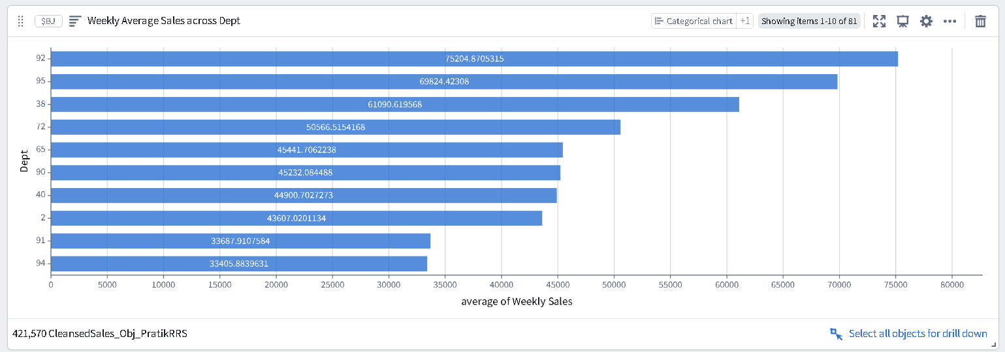

- Weekly sales by Date/time –

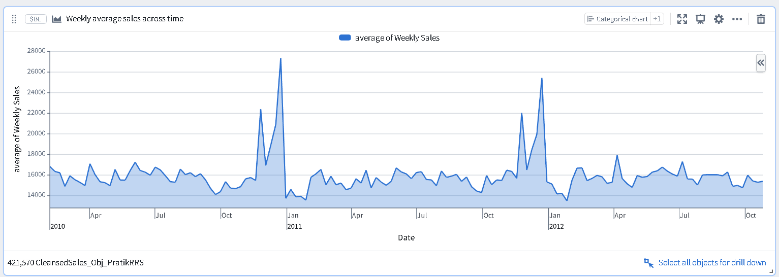

- Apply Filters and Parameters: Add parameters such as Store ID, Date Range, or IsHoliday to allow dynamic exploration of dashboards

Store ID -
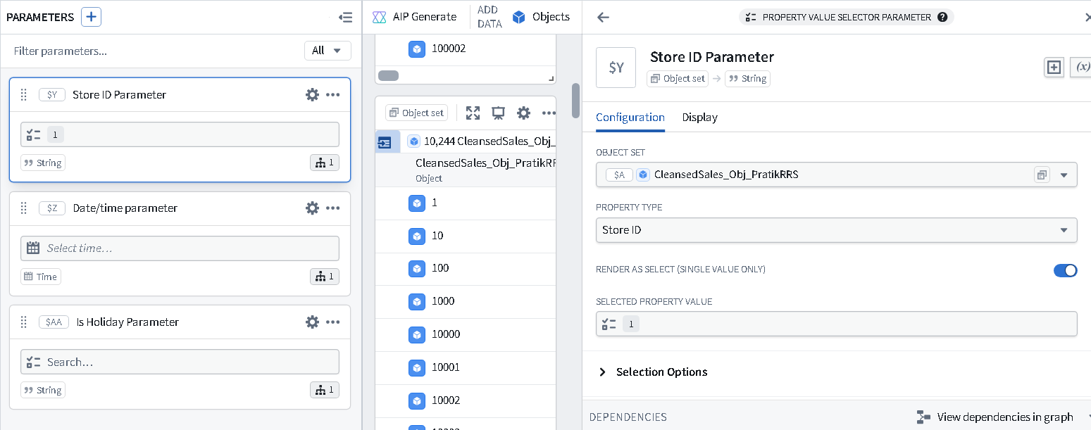
Date/Time -
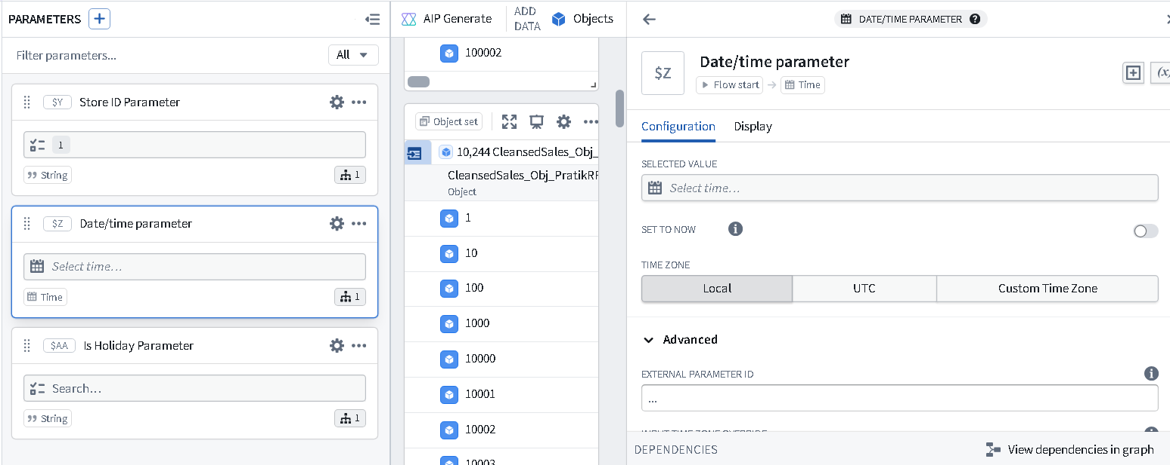
IsHoliday – 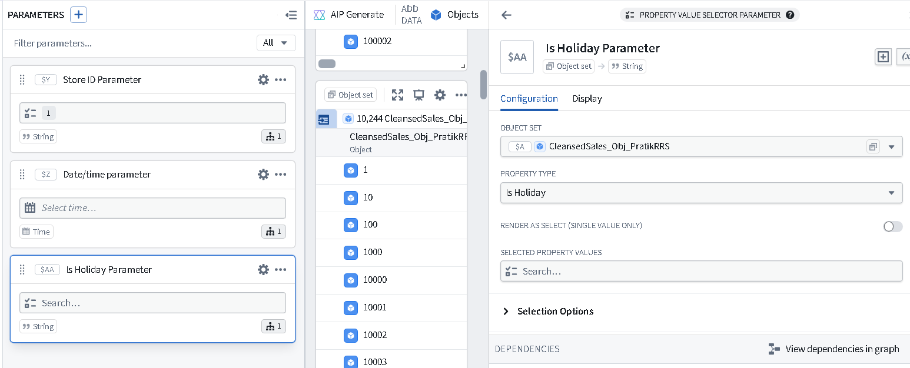
Perform aggregated queries & Insight Extraction:
Execute analysis on linked objects to derive insights like:
- Top 5 stores with highest weekly average sales.

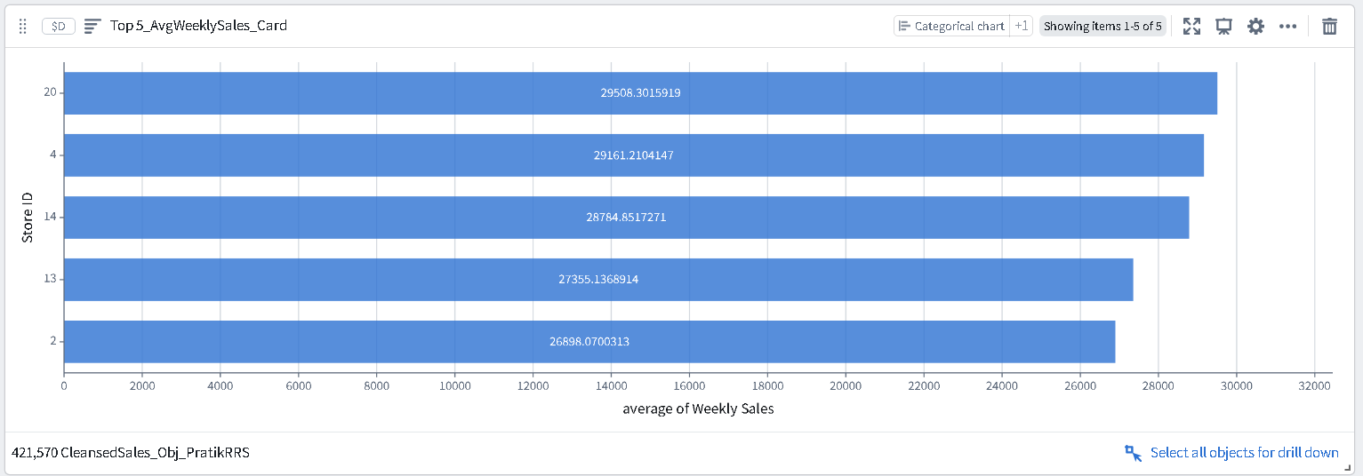

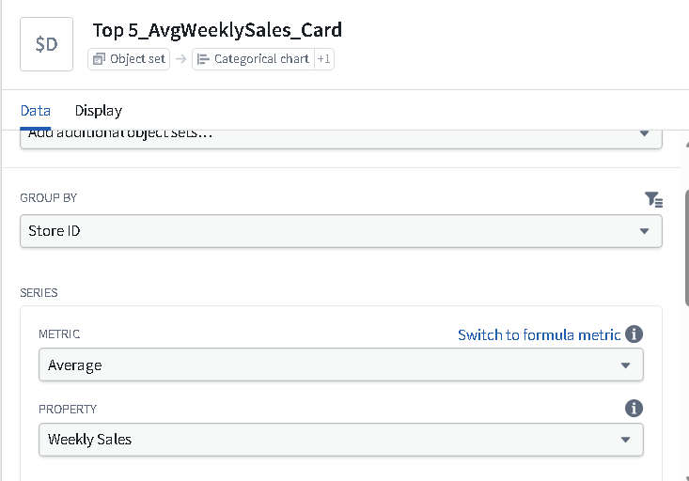

- Store Type vs. Average Fuel_Price correlation. –

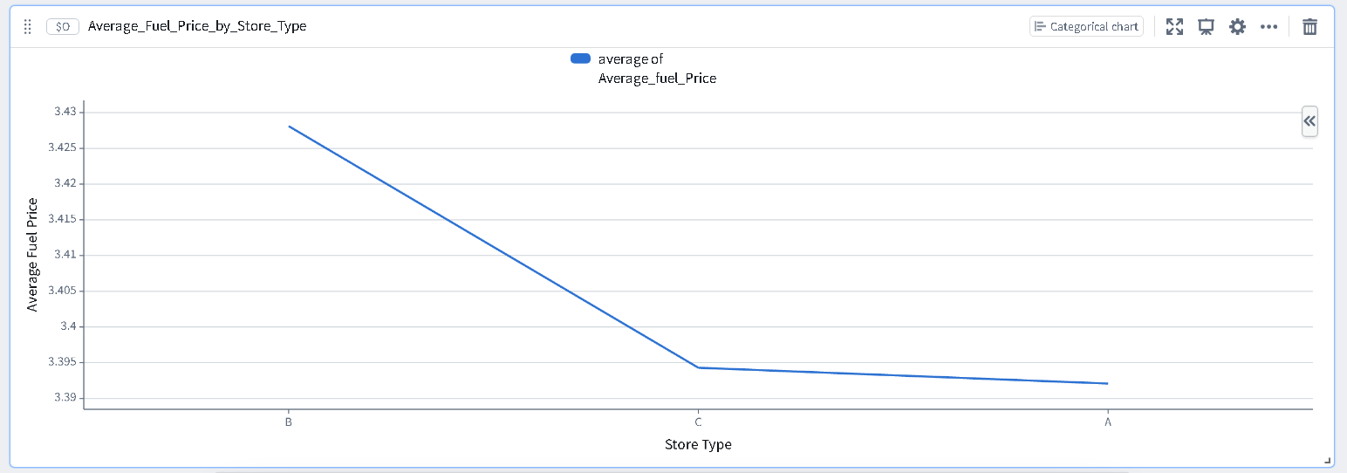
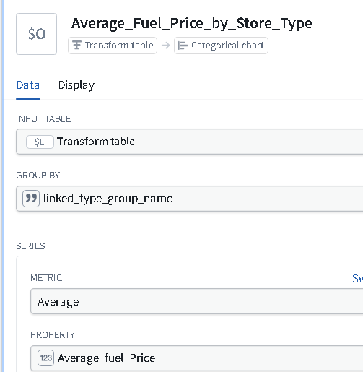

- Effect of Weekly_Sales during holidays on each dept.
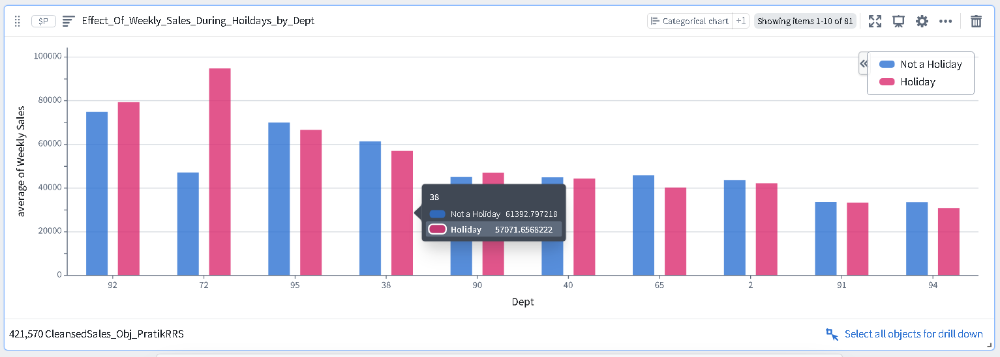
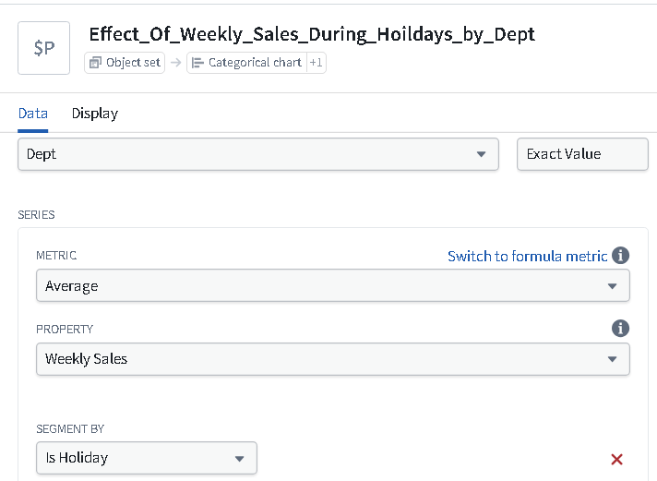

- Impact of Temperature on Store Performance
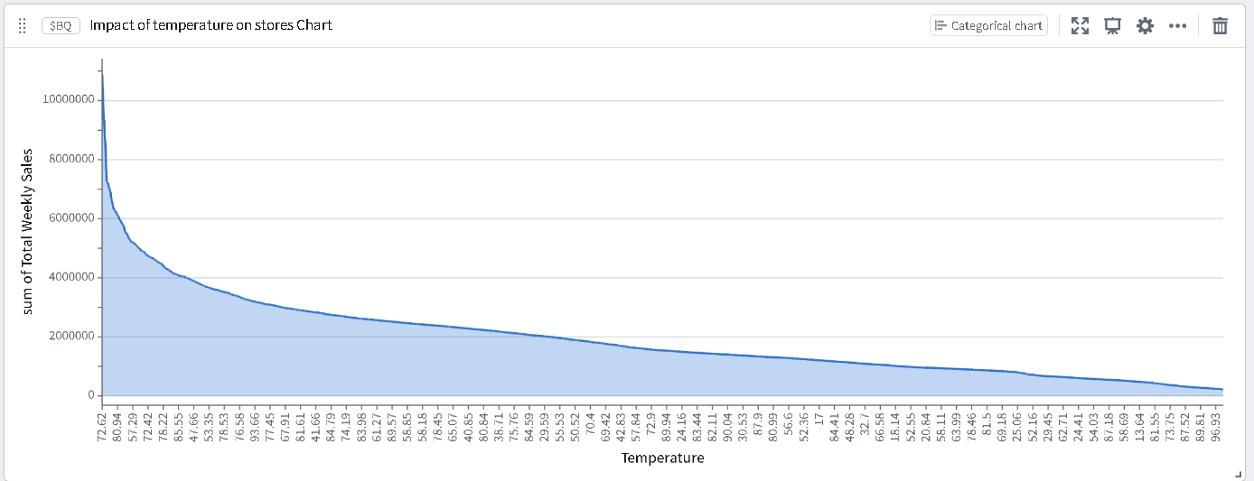
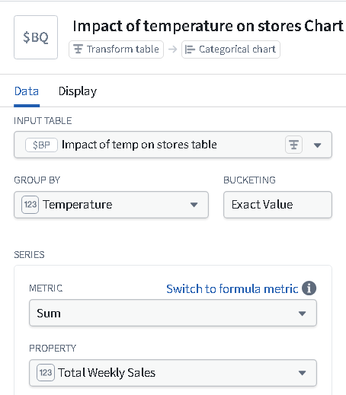

- Quiver Canvas: Combine the above analysis cards into a single Quiver Canvas to visualize overall patterns and correlations. Perform resizing, provide title wherever required.

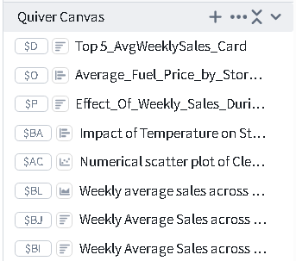

- Data Visualization using Contour –
Component Utilization: Contour was used for top-down analytical pathways, aggregating millions of rows into summarized interactive dashboards to detect temporal trends.
Data Visualization

➢ Sales Trend Analysis: Create a line chart to display Weekly_Sales trends over time for each store, highlighting holiday weeks using distinct colors or markers

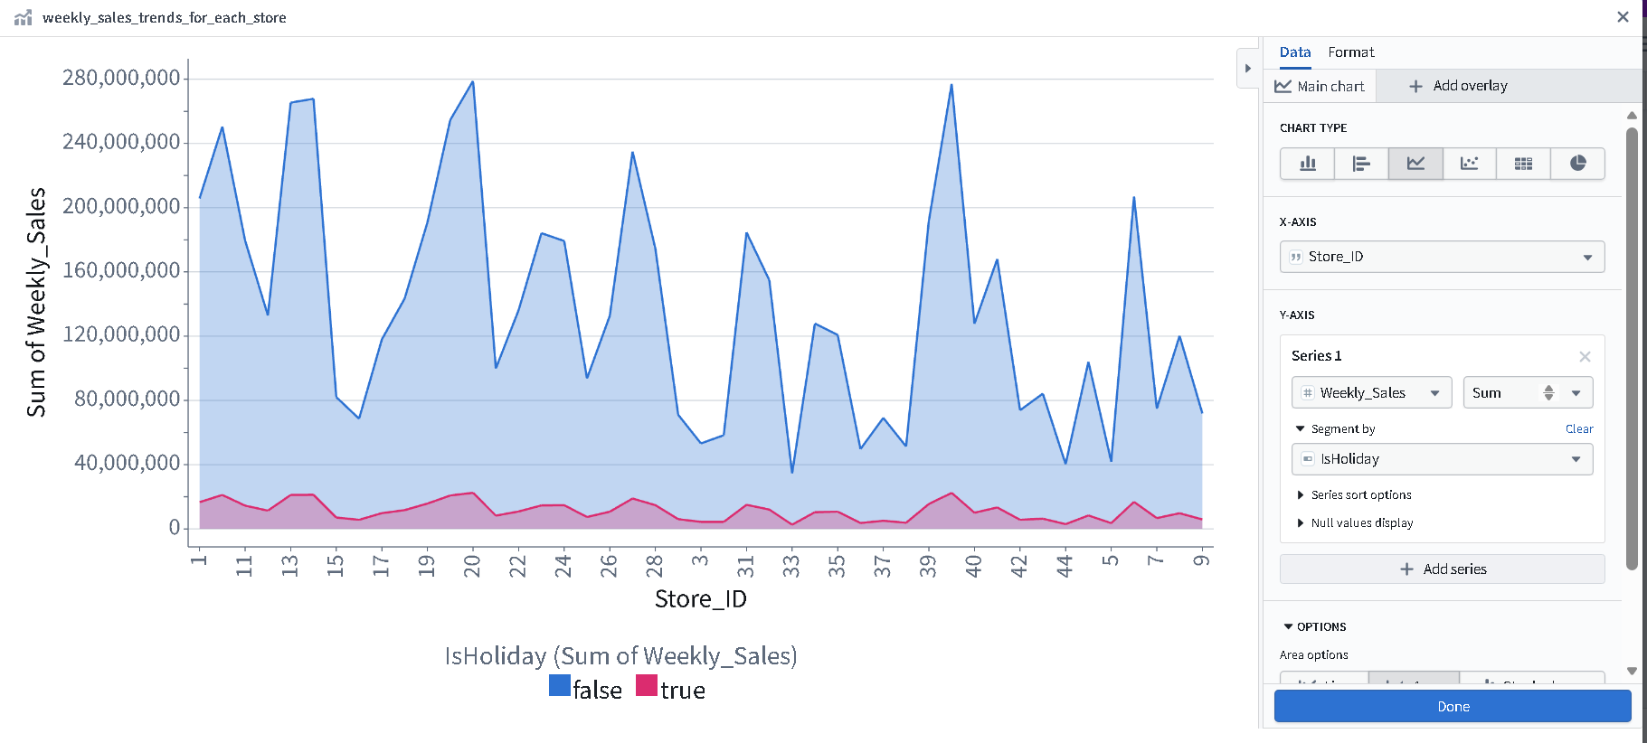
➢ Store Comparison: Design a bar or heatmap chart to compare total weekly sales across different store types during weekends and weekdays using attributes from Stores Object and Sales Object.
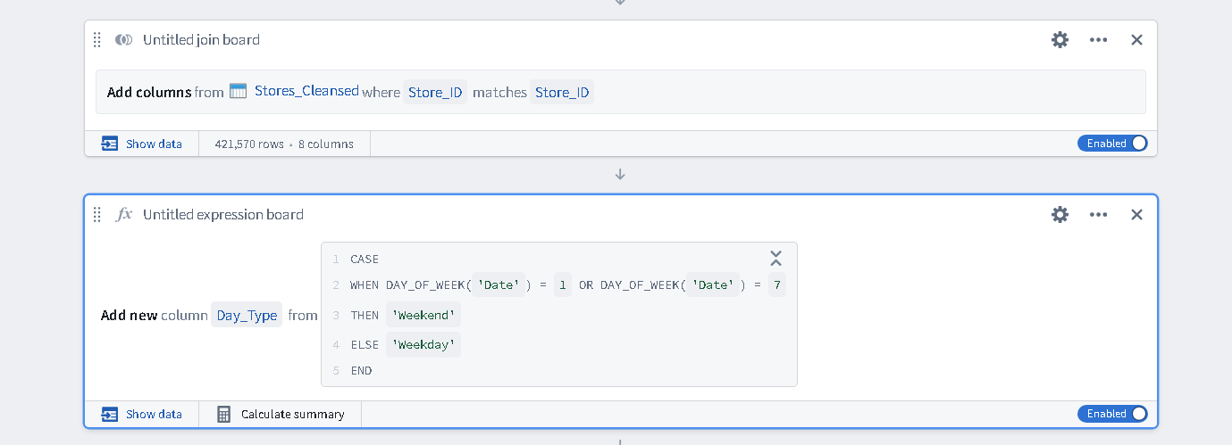
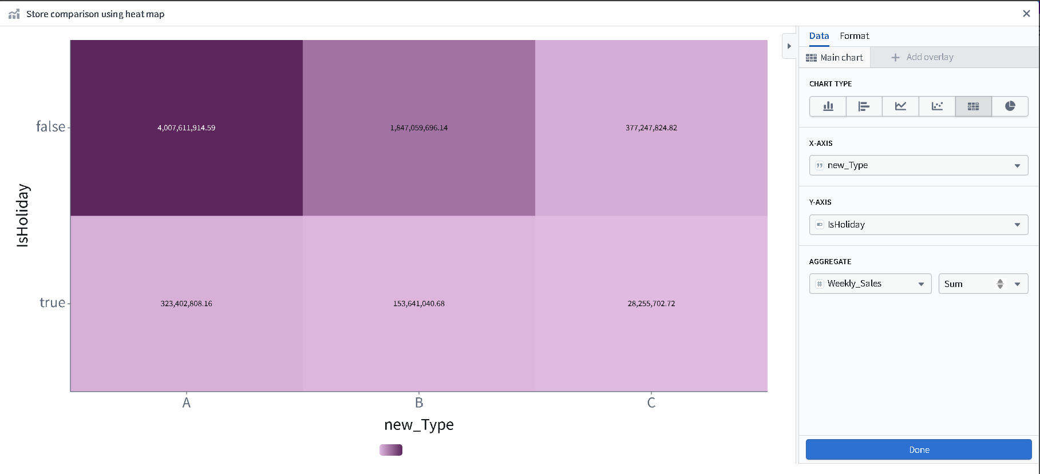

➢Summary card: Display the total weekly sales using Calculation board

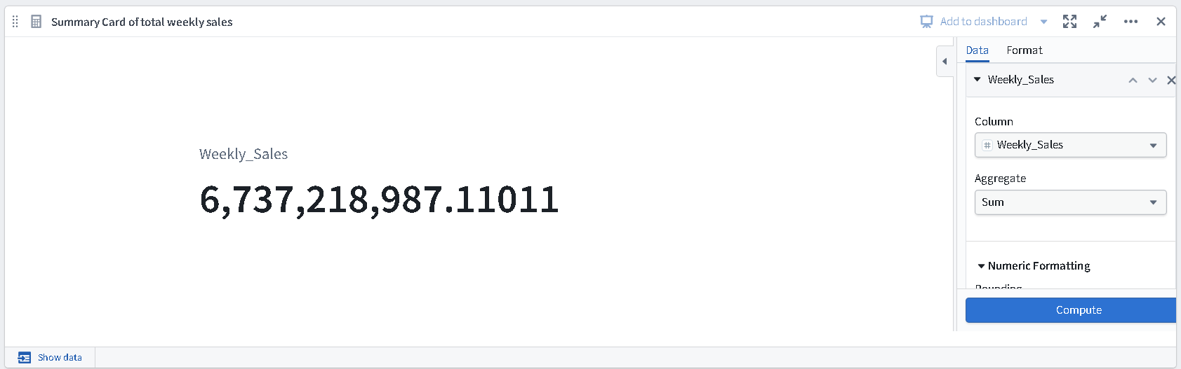

➢ Impact of Temperature on Store Performance: Display the relationship between Temperature and Weekly_Sales over week using Scatter plot or Bubble chart
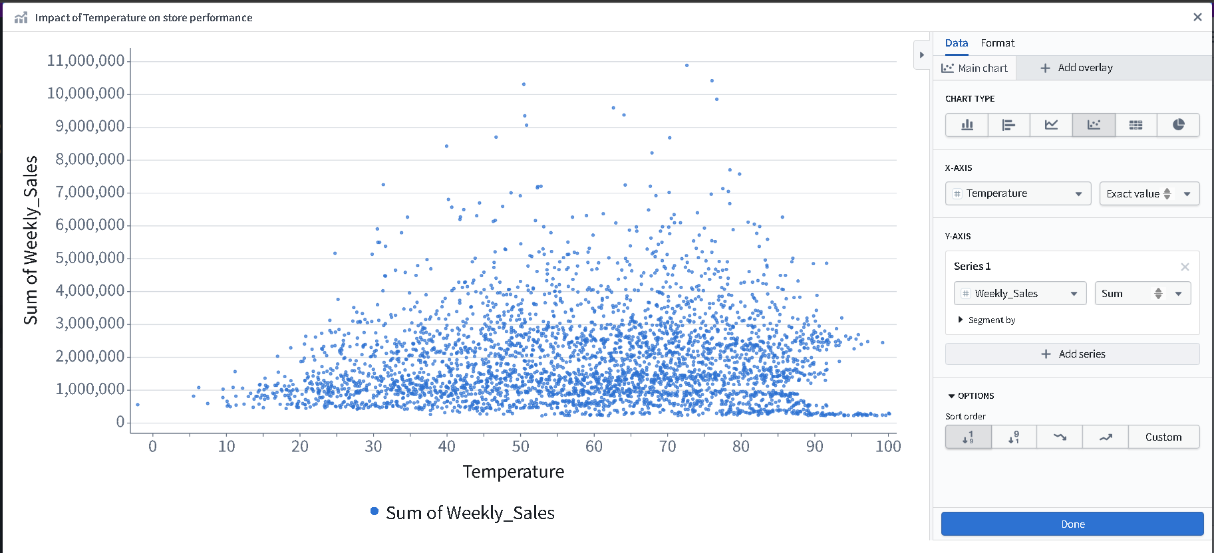

➢ Top Performing Stores: Showcase the Top 5 stores with the highest total sales using pie chart
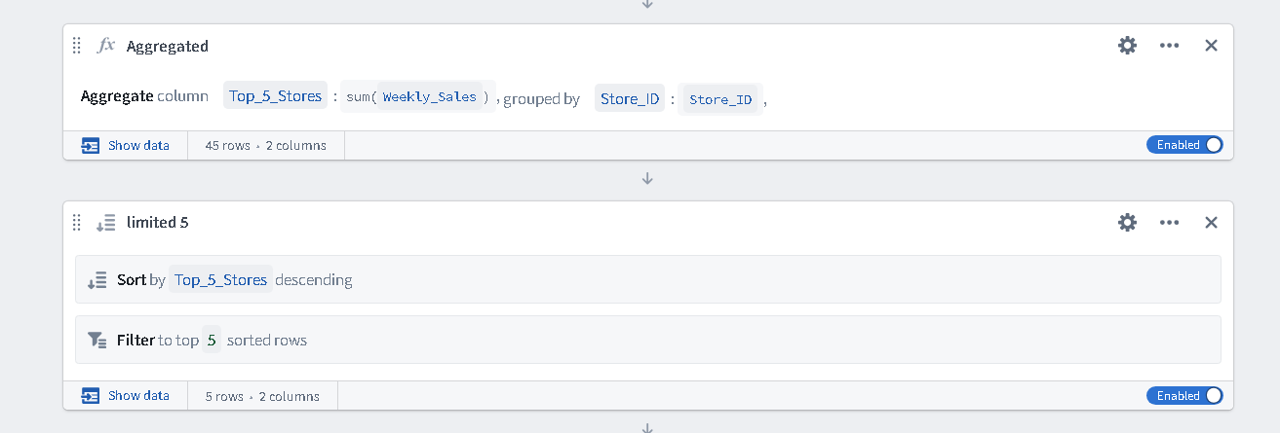

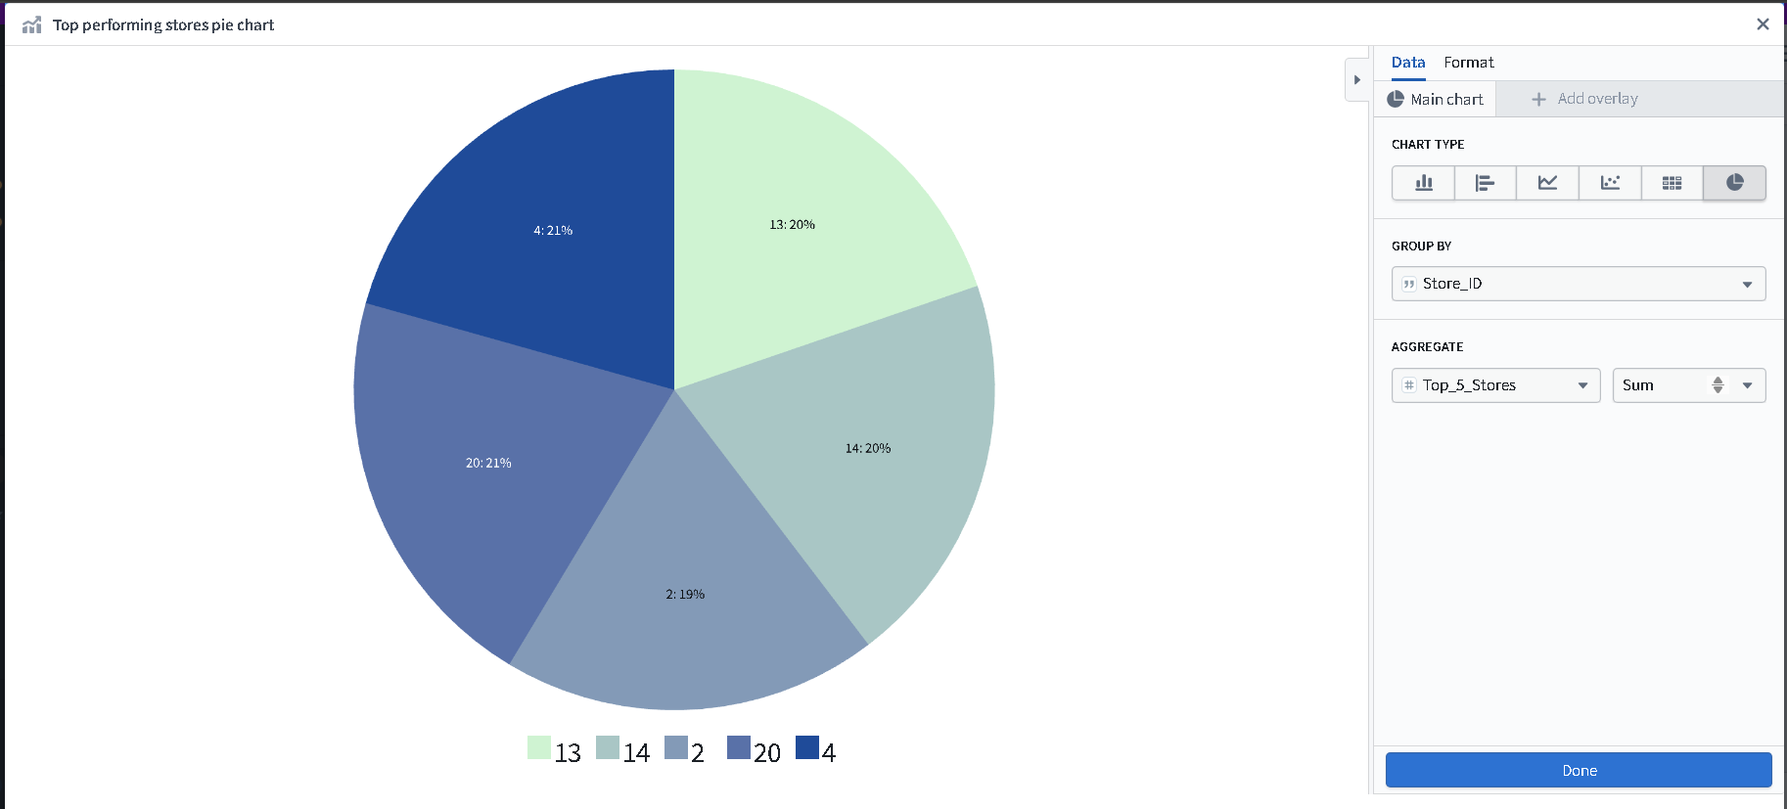

➢ Interactive Filters: Add dynamic parameters such as Store_ID, Date_Range, and IsHoliday to allow users to explore and filter visualizations interactively

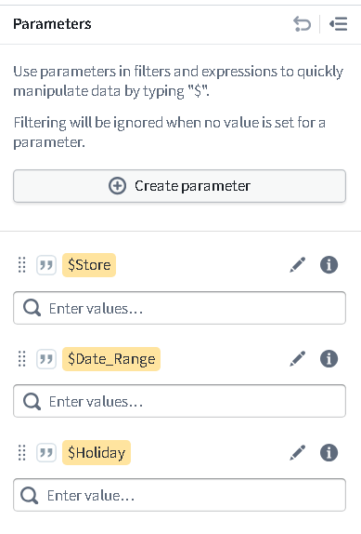

- Application using Workshop

- Build an interactive Workshop app to present insights from Quiver and visualizations from Contour.

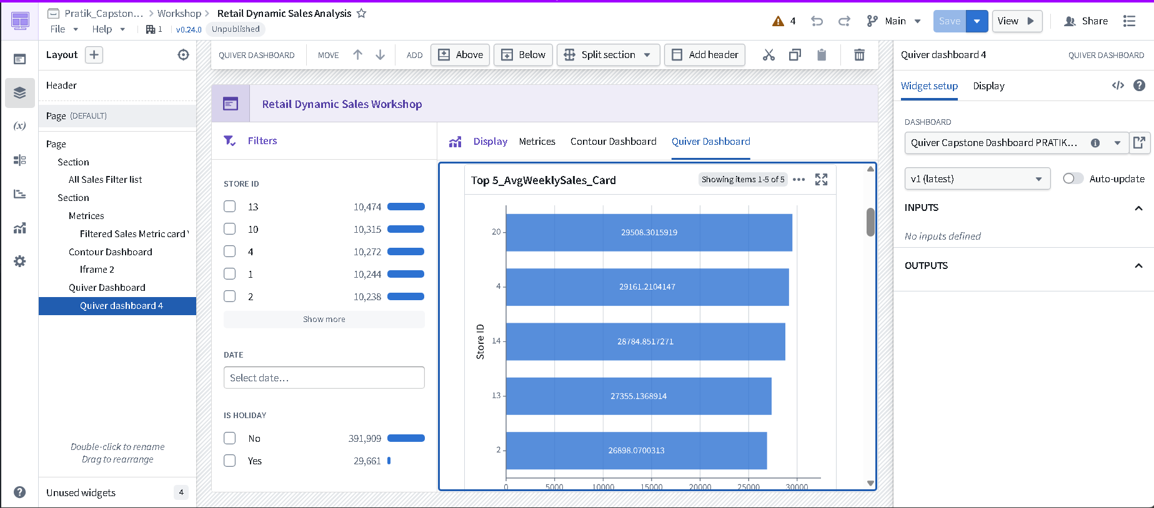

➢ Embed the Contour dashboard to allow dynamic exploration of sales data.
I used IFRAME widget to embed Contour dashboard.
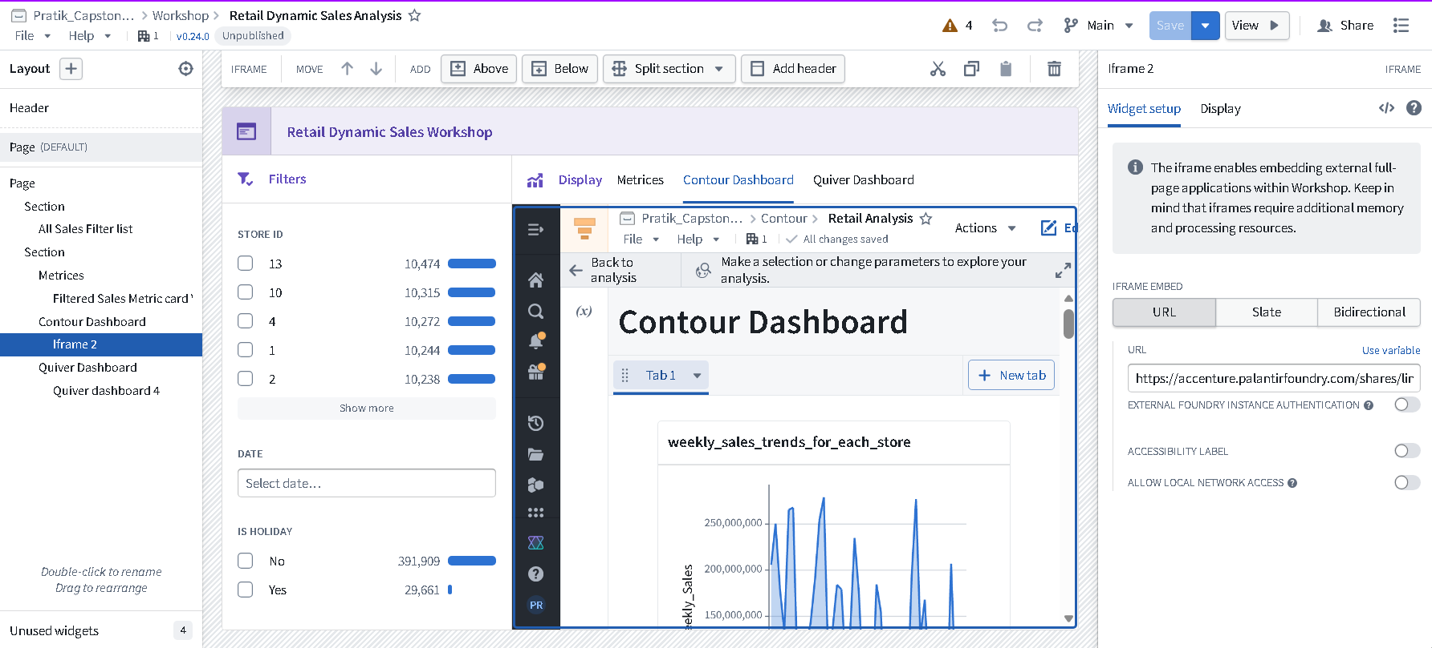

➢ Add filters for Store ID, Date Range, and IsHoliday for interactive analysis.

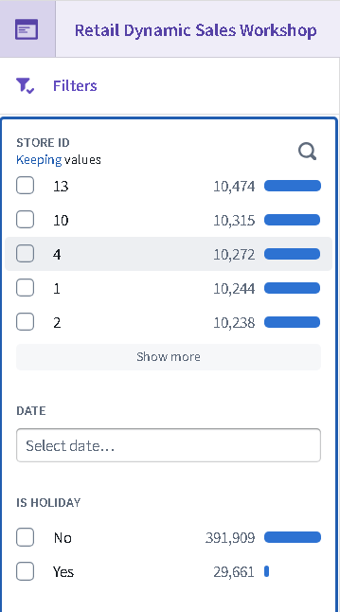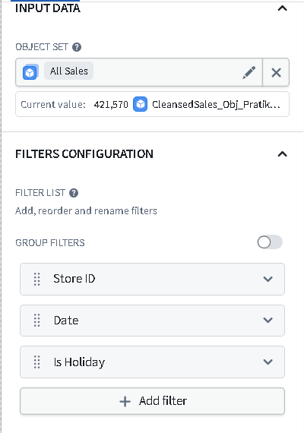

➢ Display key metrics such as Total Sales, Average Weekly Sales, and Top Performing Store.
